Final or sum

Car Objective:

After going through both the competition and critical regulations, we realized that the car gets us the most points. Hence, we had to keep a few clear objectives in mind so that we can acquire 100% of the allocated points. We divided the tasks in two:

1. Aerodynamics and Design:

Under this task, we had to achieve the following:

| 1. Drag Force of 0.4 or less | To ensure minimum point reduction from races |
| --- | --- |
| 1. Aerodynamically efficiency | To ensure directional stability and reduce drag force |
| 1. Innovative design that complies with regulations | Most of the allocated points can be lost in the criteria |

1. Manufacturing:

Under this task, we had to achieve the following:

| 1. Weight | Maintain weight as close as 50g to achieve a lighter car |
| --- | --- |
| 1. CNC milling and 3D printing | Overlook the design process to secure a millable design and decide what parts to print |
| 1. Material selection | Select materials according to needs which are durable and easy to work with |
| 1. Precision manufacturing | To acquire a model that closely replicates the CAD model |
| 1. Paint | A paint that is lightweight and provides a smooth surface |

These allowed us to visualize a final deliverable that would not only comply with the competition's regulations but also excel in innovation and performance maximizing the amount of points secured.

Initial Research

Through basic research of the forces a car experiences during its motion, we found that the forces experienced are: Thrust from the canister, Drag, Lift, Weight and downforce along with others.

Canister Thrust:

Canister thrust is a variable force that provides the prototype with the initial force to overcome its inertia. Hence, our goal was to maximize thrust efficiency by reducing inertia of the car and making it more streamlined. The nose cone design hugely impacts efficiency of the thrust and to achieve the highest provided thrust we need to design a nose cone that minimizes air resistance and is seamlessly integrated to the rest of the body.

Drag:

To reduce the drag, we had to ensure that the surface of the model was smooth and had smooth transitions throughout. Through applications of intricate designing techniques and aerodynamic principles, we had to make the model as streamlined as possible. To start with, we needed to create a front wing that would efficiently allow the airflow to be distributed over the rest of the body. Also, designing sidepods that flawlessly redirect airflow over and around the rear wheels such that it flows over the rear pods was essential.

Lift and downforce:

We had to minimize lift and maximize downforce so that our car is stable on the track and does not generate lift due to the initial thrust. To do so, we had to focus on the aerofoils of the front and rear wings, angle of attack of the nose cone and to implement ground effect.

Weight:

Heavier cars experience higher drag due to increased frontal area. Due to this, it’s harder to create downforce on heavier prototypes. Also, this hugely impacts inertia which can hence reduce the thrust efficiency. Hence, our aim was to create a model that would weigh as close to the 50g weight limit mandated by the regulations.

GENERAL RESEARCH

**Boundary Layer Separation:**

A boundary layer is a layer of fluid, which is slow-moving compared to the rest of the airflow, directly alongside a body immersed in that fluid. Boundary Layer Separation is the detachment of the boundary layer causing the formation of a wake. It occurs when the flow has reached an adverse pressure gradient where it has stopped and reversed its direction. To reduce boundary layer separation, we had to come up with a streamlined design with smooth surfaces. Filleting the edges was a major step taken in the design process as the sharp edges tended to create unwanted vortices and turbulent air flow.

Creating gradual curvature based body shapes proved to be beneficial as it maintains flow attachment and reduces adverse pressure gradients. We started to try and imply these with P7 in which we chamfered the ends of the body to replicate a gradual curve. 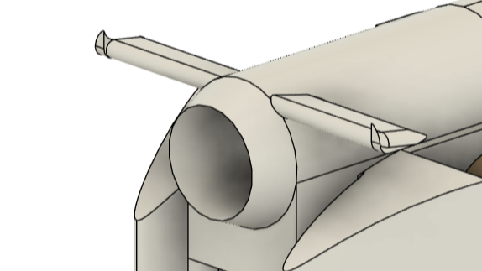

This evidently exhibited decrease in drag significantly but it hardly resembled a gradual curvature. We decided to look for ways to create a body that would replicate the tear drop shape and that came with the idea of the penguin shape.

**Wake:**

The wake is the region of turbulent airflow behind a car that is formed as it travels through air. This turbulent airflow creates a low pressure area inducing drag reducing overall efficiency.

When a body moves through air it creates a boundary layer. This layer is separated at the rear of the car creating a turbulent region with low pressure. Due to this low pressure area, a pressure difference is generated. The high pressure area at the front of the car pushes it while the low pressure area at the rear pulls it producing drag. This difference is not constant as the pressure at the rear keeps changing due to it being a turbulent area. This difference is directly proportional to pressure drag. Also, this turbulent region is more distinct with box-like rears.

Due to the wake, the car experiences a net force and can also face issues with handling.

To reduce the wake, we needed to create a streamlined design that would redirect airflow around the car.

**[PIC]**

**Magnus Effect:**

Experienced by the wheels in this case, Magnus effect is the phenomenon where, when the wheels come in contact with a fluid while moving in the opposite direction, they experience a force in a direction perpendicular to the direction of its motion. Here, wheels travel in the opposite direction of the airflow and a high pressure area is created on bottom. Due to the low relative velocity on top of the wheel, it experiences a low pressure area at the bottom of the wheel. Due to this, both a high and a low pressure area is realized, due to which a drag is experienced by the wheel. Basically, the relative speed of a wheel on top is faster than that of the vehicle and at the bottom is slower, creating rotational turbulence, inducing drag. To overcome this we needed to design a front wing that would reduce the contact of incoming airflow and the wheel.

**[PIC]**

**Centre of Mass determination:**

The center of mass of an object is the point at which the relative distribution of weight sums up to zero. For a symmetric object, the COM is in its geometric center whereas for an irregular object, the COM is at a point where the object can balance.

We considered the following to determine an approximate position for the COM:

Tipping force: (Rear COM)

The thrust provided by the CO2 canister becomes the tipping force for the car and the moment of force provided by the center of gravity of the car helps balance it out. So, our aim was to ensure that the torque provided by the tipping force should always be less than the torque by the center of mass.

where T is the force provided by the canister,

W is the weight of the car,

d is the perpendicular distance between W vector and the center of the front wheel,

h is the perpendicular distance between the T vector and the center of the front wheel.

Hence, we needed to ensure that the maximum force provided by the canister should be less than the right hand side (RHS).

From the equation, we see that we can maximize the RHS by either increasing the values of *W* or *d*, or by decreasing the value of *h*.

Since increasing the value of the weight of the car is unfavorable for other factors such as low inertia, and the value of *h* remains almost constant throughout the models, the only value we could afford to change was *d*. Hence, for a higher value of *d*, the center of mass was to be shifted to the back.

However, we can’t place the center of mass way towards the rear as it promotes oversteer, i.e. the car would turn more easily with a minimal force applied. Hence, we also considered directional stability of the car to balance this out. Another disadvantage of this was that it would enhance traction during the crucial moments of acceleration provided by the thrust because a high level of traction is very unfavorable as it slows down the rate of acceleration. Traction, simply put, is the frictional force which resists acceleration and helps the wheel to grip to the surface. Going by this, we can’t have extreme levels of traction so we aimed to achieve a traction in between high and low.

Directional stability: (Forward COM)

To induce understeer, we need to promote directional stability in the body which would make the chances of the car turning or changing paths less. To do so, we visualized and realized that a forward center of mass would help in maintaining the directional stability of the car along with producing lower traction in general.

To brief it up:

| **Forward COM** | **REAR COM** |
| --- | --- |
| Promotes directional stability | Prevents the tipping moment |
| Promotes understeer | Promotes oversteer |

From this table, we thus realized that balancing these factors is crucial and a COM right at the middle would be the most preferable for a favorable race time. Hence, after incorporating in the CO2 canisters in our model and setting the materials of 3D printed parts (i.e. front wing, rear wing, tether line guides,etc.), we achieved a center COM in the car:

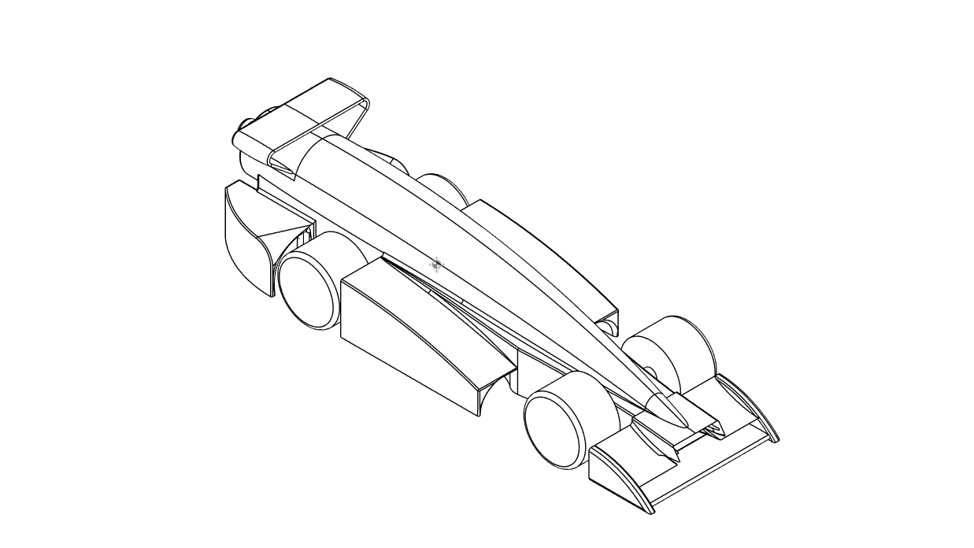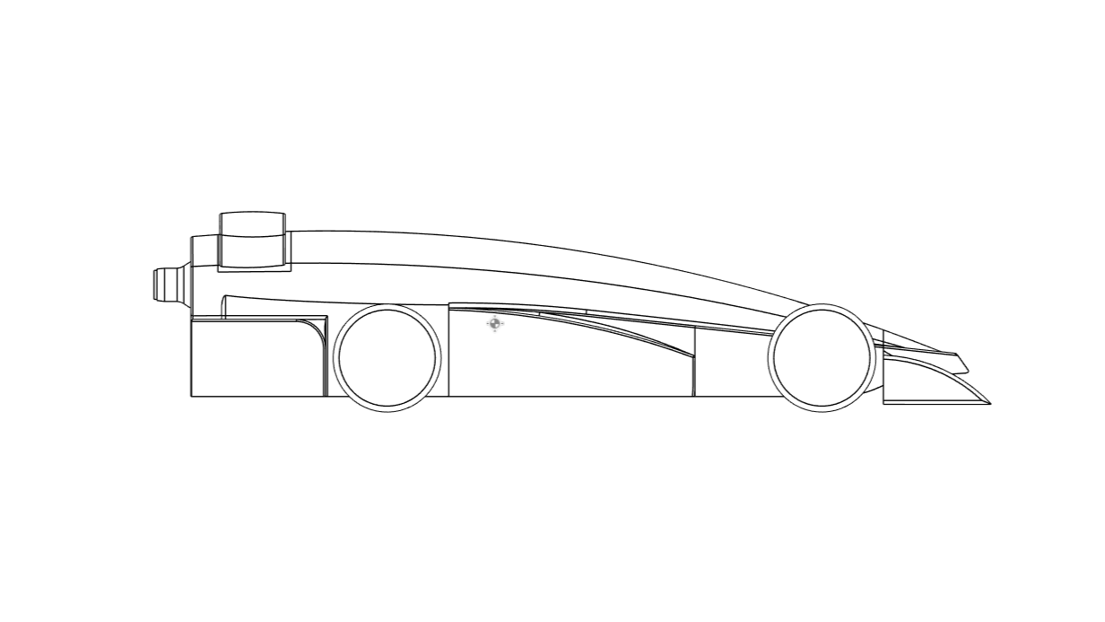

**[USE SECOND ONE IMO]**

The Centre of Mass tool displays a symbol at the observed Centre of Mass of the model. If all the materials are entered correctly, it displays the assumed Centre of Mass of the body. Indicated by 

**FOR CAD:**

* What is CAD?

Computer Aided Design is the utilization of computers in support for designing, optimizing and analysis of any design.

The usage of CAD has proven to ease the storage, shareability and collaboration within engineers. There are 3 types of CAD softwares:

1. 2D CAD:

Aid the sketching and annotating process of a design. Mostly used for planning and layouting.

1. 3D CAD:

Aid the 3D modeling part of the designing process. 3D CAD provides an additional axis Z to facilitate 3D modeling.

It is made possible through wireframing and meshing. Wireframing is the skeletal representation of a real-world object whereas meshing is the process of dividing a complex object into smaller cells/elements.

3D CAD is of three types:

1. Parametric Modeling:

It allows users to define constraints and dimensions and edit them as soon as they have been defined. Using parametric modeling software, repetitive modifying is simplified but the existence of a history tree can stir up issues if major changes are made.

1. Explicit Modeling:

Unlike parametric modeling, explicit modeling does not rely on a history tree. The defined constraints and sketches directly become a part of the geometry created. Due to the absence of a history tree, repetitive modification is easier and expeditious. This flexibility gives the engineers the ability of rapid prototyping.

1. Assembly Modeling:

The incorporation of multiple pre-existing geometries into one.

1. Free Form CAD:

A technique that allows for the creation of more organic and graceful surfaces and solid shapes. It works on the concept of control points, splines and subdivisions. Free Forms can be combined with both parametric or explicit modeling to form complex geometries. Though it has its plus points, it is a complex technique which, if not executed well, can lead to complications like irregular transitions between two surfaces.

| 2D CAD | Aid the sketching and annotating process of a design. Mostly used for planning and layouting. |
| --- | --- |
| 3D CAD | Aid the 3D modeling part of the designing process. 3D CAD provides an additional axis Z to facilitate 3D modeling.  It is made possible through wireframing and meshing. Wireframing is the skeletal representation of a real-world object whereas meshing is the process of dividing a complex object into smaller cells/elements.  3D CAD is of three types:   1. Parametric Modeling:   It allows users to define constraints and dimensions and edit them as soon as they have been defined. Using parametric modeling software, repetitive modifying is simplified but the existence of a history tree can stir up issues if major changes are made.   1. Explicit Modeling:   Unlike parametric modeling, explicit modeling does not rely on a history tree. The defined constraints and sketches directly become a part of the geometry created. Due to the absence of a history tree, repetitive modification is easier and expeditious. This flexibility gives the engineers the ability of rapid prototyping.   1. Assembly Modeling:   The incorporation of multiple pre-existing geometries into one. |
| Free Form CAD | A technique that allows for the creation of more organic and graceful surfaces and solid shapes. It works on the concept of control points, splines and subdivisions. Free Forms can be combined with both parametric or explicit modeling to form complex geometries. Though it has its plus points, it is a complex technique which, if not executed well, can lead to complications like irregular transitions between two surfaces. |

[I ADDED THE TABLE JUST IN CASE U WANNA DO THAT SO YEE ITS THE SAME THING]

* Picking a software:

| **Fusion** | **Solid Works** | **Space Claim** |
| --- | --- | --- |
| Parametric/Explicit | Parametric | Explicit |
| Cloud Based | Not cloud based | Not cloud based |
| Simulation Tools | Simulation Tools | Ansys softwares have to be integrated |
| Manufacturing Integration | Manufacturing Integration | Ansys softwares have to be integrated |
| Free for students | Subscription | Free for students |
| Ease of usage | Ease of usage | Ease of usage |

* Based on the above gathered information on the three of the reputed softwares, a decision had to be made to pick the ideal modeling application.
* Keeping affordability, cloud storage, user friendliness and access to training resources in mind, we chose to go with Fusion. Solid Works was immediately put aside due to its unaffordability and its high system requirements of 16 GB RAM and a quality GPU.

Space Claim was overlooked due to it being an explicit modeling software which would make it harder to edit dimensions and constraints if needed to. With the advantageous history tree, there would be no need to start geometries from scratch. Without constraints and parameters, it would’ve been hard to keep track of the design intent. Also, monitoring various parts of assemblies would be less efficient since design intent and interpart relationships are not maintained.

* Important features:

1. Sketches:

Sketches are the foundation of any geometry to be created as they define the design intent. In Fusion, shapes like circles, rectangles, ellipses, arcs, etc. are provided to ease sketching along with splines and constraints. Unconstrained sketches (indicated by:  in Fusion) are useful for their flexibility and experimentality, but can affect the complex assemblies later on. Hence, it is important to create Constrained sketches (indicated by:  in Fusion) once the design intent is clear to obtain a precise model.

1. Solids:

Solids are formed from sketches. Among the numerous functions Fusion provides, Extrude (indicated by: ), Loft (indicated by: ) and Sweep (indicated by: ) proved to be the most beneficial among all as evident later on.

Extrude tool adds depth to sketches. It can also be used to join (), cut () or intersect () two (or more) bodies. Loft tool creates smooth geometry between two sketch planes. Sweep tool creates a solid body along a path with a defined profile and can perform the same operations as Extrude and Loft.

1. Tools for modification of Solids:
2. Fillet:

Fillet tool () smoothens the edges of a solid body by rounding them or by adding material between two edges.

1. Chamfer:

Chamfer tool () bevels the edges of a solid body by eliminating material at the edges.

1. Combine:

Combine tool () either joins or intersects two separate bodies.

1. Align:

Align tool () aligns two separate bodies using a coordinate system.

1. Planes:

Construction Planes allow sketching in places where planar faces do not exist. These planes could also be used to use tools like Split Body (). Construction Planes can be formed at an offset from a face, at an angle or at a tangent to a surface, etc.

1. Surfacing:

Surfaces are 2D geometries that could exist on their own or as a part of a solid. Surfacing refers to the process of creation and manipulation of these 2D geometries. Basic Surfacing has been used later on during the process to increase smoothness and increase the aerodynamic capability of the models.

Functions Patch () and Stitch () proved to be the most useful in the process of perfecting the model.

**FOR CFD:**

* What is CFD?

Computational Fluid Dynamics is the utilization of computers to simulate the flow of fluids in different situations. It utilizes algorithms to solve the equations of fluid flow. A CFD software helps in turning a physical situation into a mathematical one which makes the simulation, visualization and analysis effortless.

The geometry which has to be analyzed is first partitioned into a mesh of small cells. The equations are then applied to each cell and the behavior of fluid within each one is analyzed which then represents the fluid's behavior over the entire geometry.

While running tests, we noticed that the boundary walls created by AutoDesk CFD significantly impacted the calculated drag force. To overcome this issue of variability, we decided to define a boundary box with identical dimensions for each and every simulation run.

CAR DEVELOPMENT

**Front Wing:**

Aim: Our aim was to come up with a front wing design that redirects incoming airflow around the wheels.

Our first approach was to create it at an angle with support structures at the ends. This did not give us favorable results due to poor CAD modeling.

With our 2nd prototype, we decided to design a curved front wing with an abrupt curvature. This showed promising results but we still needed to step up our modeling process.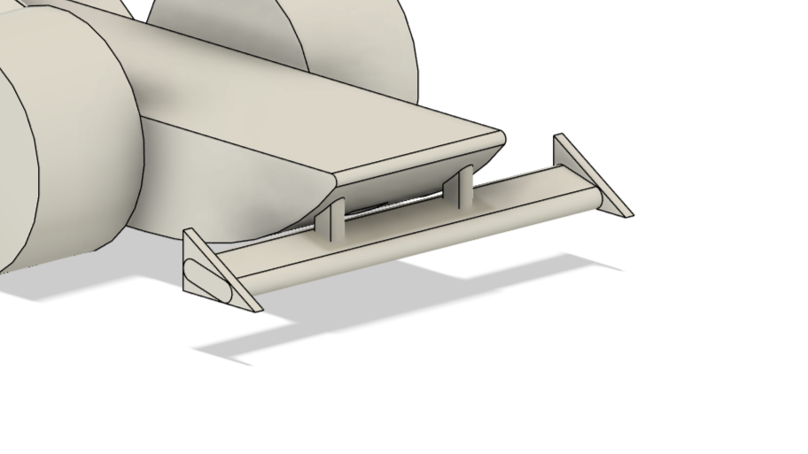

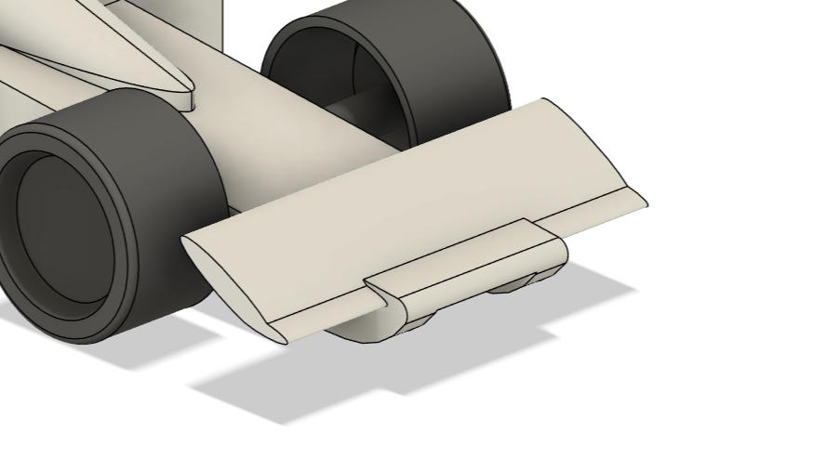

With the third prototype, we managed to achieve a wing with a gradual curve. This design resulted in an overall 20% decrease in drag. We felt confident with this design and decided to improve on the same. 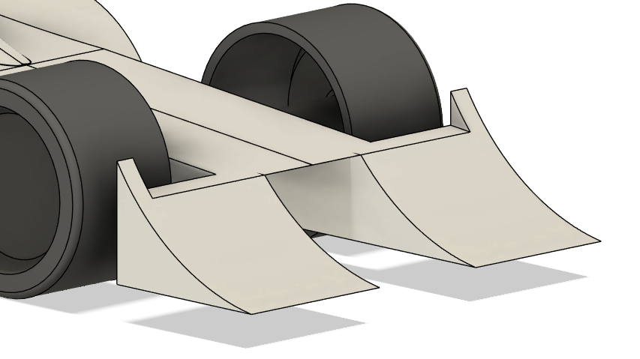

In the next few models, we decided to flatten half of the wing. Due to this, there was an abrupt airflow separation which directly impacted the wheels.

With the 6th prototype, there was a gradual curve on both the top and side of the wing. With this design, our intent was to redirect air flow both on top and to the sides of the wheels. We did not see any significant change due to this addition and did not pursue it. 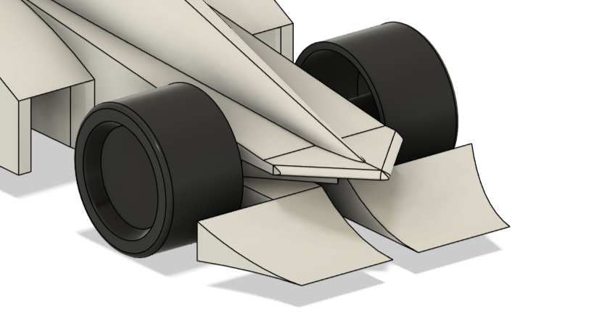

P7 was the pinnacle of both, a streamline and a well CAD modeled prototype. We achieved a drag force of 0.37 and was chosen as a base model to make minor changes to and experiment. After many iterations of similar designs, we decided to experiment with double elemented front wings with the curved element as basis. We tested two types of double elemented wings: straight element above (S1) and straight element below (S2).

With the S1 iterations, we saw an increase in drag force and chose to not consider it. With S2 iterations, we saw room for improvement.

S2 allowed for better boundary layer control and aerodynamic efficiency. It helped in pressure recovery which reduces drag.

Pressure recovery refers to the process of converting the kinetic pressure of a fluid to static pressure. Basically, the straight element slows down the flow of fluid, which in turn changes kinetic pressure to static. This allows for equal pressure distributions throughout the surface, decreasing drag.

Keeping the above in mind, we made minor changes to the S2. Our main focus was to come up with an aerofoil and to decide the perfect placement. We came to a conclusion that the placement of S2 will have to be in the front due to both aerodynamic efficiency and regulations which will be discussed ahead.

With the creation of Prototype Noctua, we achieved new horizons. The curved element had curvature both above and below. 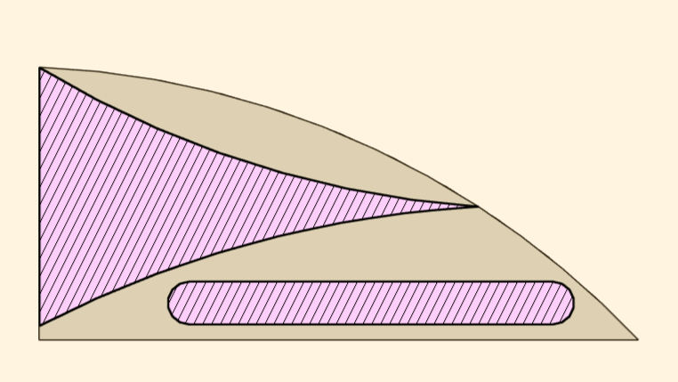

With the curve below, we aimed to decrease the direct impact of air on the wheels. There is a lesser curvature on the bottom as compared to the top as we did not want to create too much lift. With this iteration of the front wing we achieved an overall drag force reduction of 31.87%.

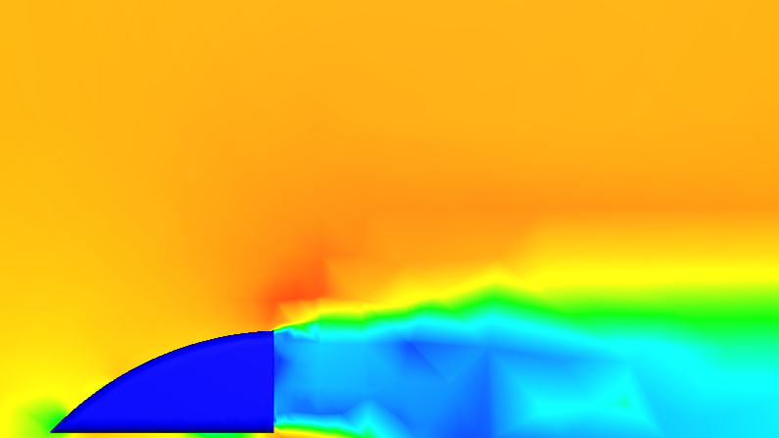

The above represents, in the cross-sectional form, the airflow around the final prototype of the front wing. As seen, the curved part of the front wing successfully redirects the passage of air above creating a wake behind the wing.

**Rear Wing:**

Aim: With the rear wing, our aim was to create a low drag, high downforce model. The model was to maintain a balance between the downforce created by it and the front wing.

With the first prototype, we dived in blind to what to expect from a rear wing other than downforce creation. With the next few models, we tried different designs to broaden our domain for the design intent. With thorough simulations, we weren’t satisfied with the results.

We randomly stumbled upon winglets, directly influenced from airplanes. With all the prototypes created before, one major issue was the creation of vortices by the ends or rear wings. This issue was solved with the implication of blended winglets. These new winglets showed immediate improvements in reduction drag. 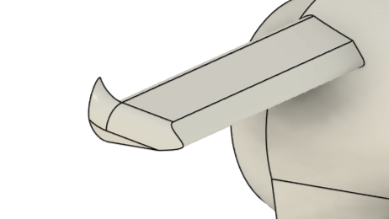

But with the creation of winglets, the issue of creation of vortices was not completely resolved. To completely eliminate vortices we decided to create a wing that resembles a F1 car. The ‘curved wing’ concept used in F1 reduces drag significantly. But the regulations of the competition differ from the ones set by F1 In Schools and so we had to modify them so that they follow them. We ended up with an inverted triangle as our rear wing.

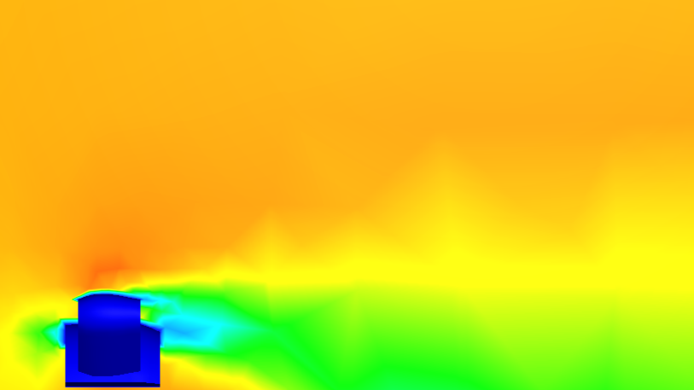

The first of the two chosen prototypes, though effectively helped in managing the turbulent air flow that would be created in the wake of the car hence reducing drag, had us concerned with its structural integrity as it was modeled to be wafer-thin to maintain the low drag aim. Hence, we had to discard this prototype. But this set a foundation for the design intent of the final rear wing.

This final prototype was modeled to have a thicker leading and trailing edge. It was raised higher to maintain the required 3 mm distance mandated by the regulations. The support structures were angled lower to cover a larger area of airflow. This helped us improve the structural integrity significantly while maintaining the design intent.

We used the NACA 0012 for these iterations of the rear wing. It provided close to no lift at the 0° angle of attack. Due to its symmetry, it could be easily manufactured with great structural integrity and predictable aerodynamic characteristics. 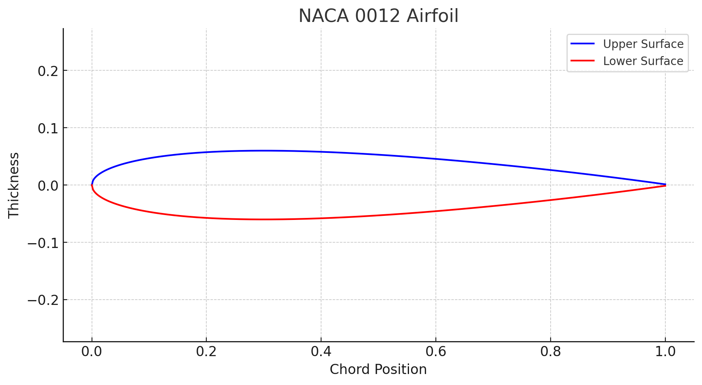

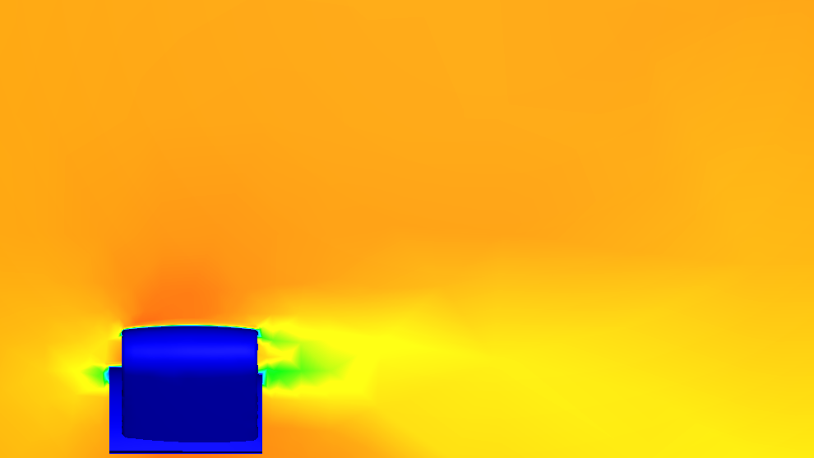

While being a more streamlined design by almost 30%, it also proved to be more efficient in maintaining the energy of the airflow it faced. Hence, this design was chosen as the final rear wing.

**Sidepods And Rearpods:**

During the initial phase of designing, we focused on perfecting the front and rear wings. Even still, our design intent gets its foundation from the first few models.

**Aim:** Our aim was to create sidepods such that they redirect airflow over the rear wheel and to ensure smooth flow along the sides.

Our thought process led us to creating hollow sidepods, which would prove to be helpful in minimizing wake turbulence and increasing downforce and stability of the prototype on the track. Our initial design was an opening right into the rear wing, which remarkably reduced drag but could have been improved.

Then it was decided to create an opening towards the sides of the car. Implementing this on P7, we achieved our first exceptionally streamlined model. 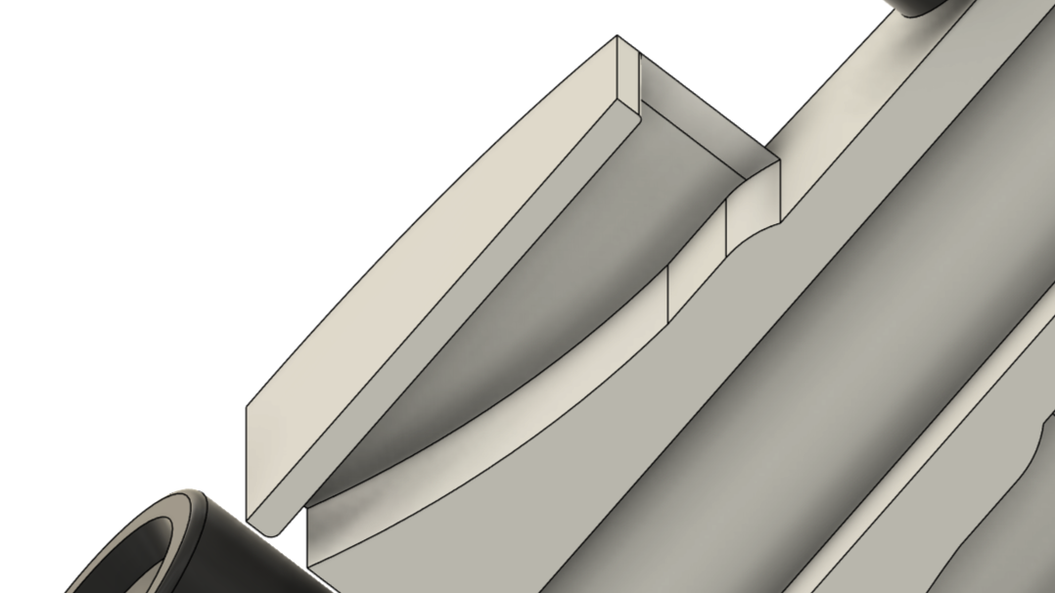

With rigorous analysis through CFD, we realized that this design, with its benefits also had its drawbacks. The opening for the airflow to pass was miniscule. This would trap a significant amount of airflow and redirect it under the car diminishing ground effect. Also, due to the use of the 6.35 mm diameter drill bit, the manufacturing of the tiny opening would’ve been impossible. This was later rectified in P7.

This and the passion for a lower drag prototype led us to hollowing them in such a way that the passage opens to the tether line guide slot.

Along with this, we lowered the sidepods significantly. Through analysis we noticed that the airflow right above the front wheels would slip into the low pressure area created behind the wheel creating turbulent airflow into the sidepods. Hence, it allowed the sidepods to work more efficiently than before and regulate airflow as intended to. Lowering of sidepods helped in moving the center of mass down as well. 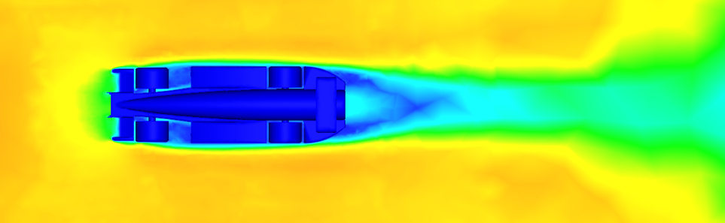

From the CFD analysis of the prototype, it is seen that the low pressure area behind the wheel as well as airflow along the sides is maintained throughout.

**Aim:** Our thought process, when we were coming up with designs for the rear pods, was to use them to redirect the passage of air to the rear low pressure area of the car.

We ran through multiple iterations and ended up, once again, with a V. This design allowed for the airflow from the tether line slot to spread up and for the flow from the sides to be averted towards the rear. 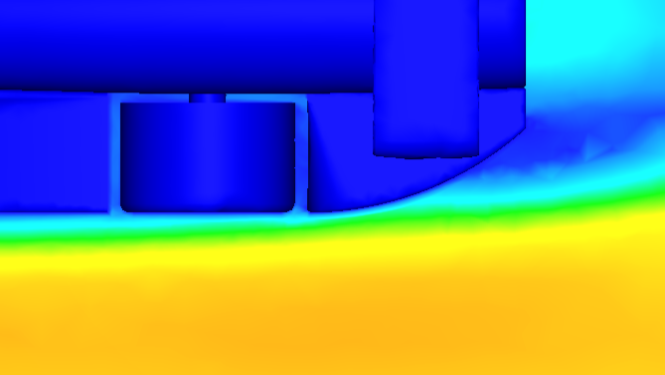

Due to the slope of the rear pod, the airflow is not fully pivoted to the rear but there is a late separation of air flow which was ideal.

With P6 and P8, we tried to hollow out the rear pods as some of the airflow would get trapped between it and the rear wheel. But due to poor CAD modeling, this strategy did not prove fruitful. This plan was originally thought to be discarded but made a return with the final few versions of Noctua. 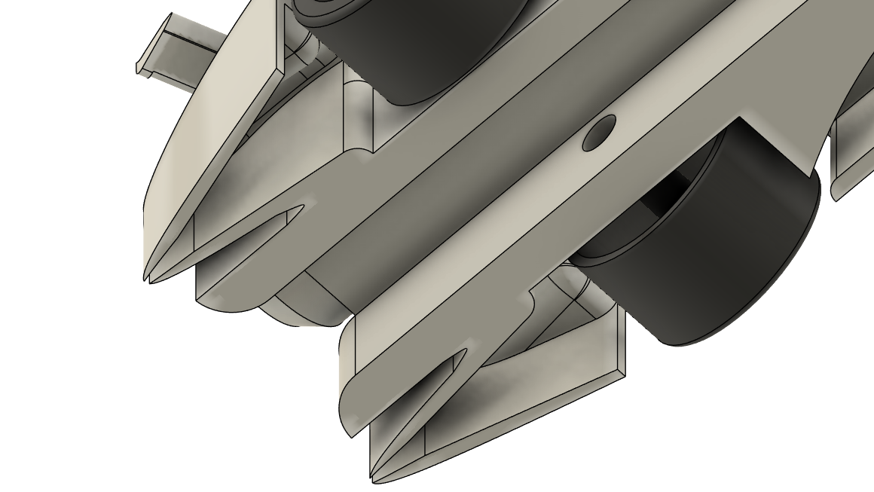 With the improved modeling efforts, this hollowing, though not a cake walk, proved yielding.

All these changes to the side and rear pods helped in streamlining the car the most. It proves how important these two components are for directional stability, aerodynamic efficiency, generation of downforce, etc.

**Nose Cone:**

**Aim:** Our aim with the nose cone was to create a flat surface that would not let the airflow flip onto the wheels.

Initial designs led us to realizing that the airflow would roll over into the wheels and hence we decided to go with a more refined nose cone. Taking inspiration from a sword, the nose cone created for models P6-P9 served its purpose right, slashing through the wall of incoming air and significantly reducing the slip-off factor. The junction between the nose cone and the main body was sharp and had to be filleted with a G1 continuity factor to smoothen the transition.

We later switched the design to a wedge as the ‘edge of a sword’ concept, despite its functionality, resulted in a sudden impact from the incoming air, leading to occasional turbulence.

**Car Body:**

The most streamlined shape in the world is the teardrop with a drag coefficient of 0.05. But during the design process of the body, we realized that implication of such a shape would not be possible. We decided it would be best to elongate the body so that there is a gradual flow of air along it. Chamfering further reduced the drag but was not satisfactory. 

To overcome this we needed to brainstorm a solution that would result in a penguin-like shaped body.

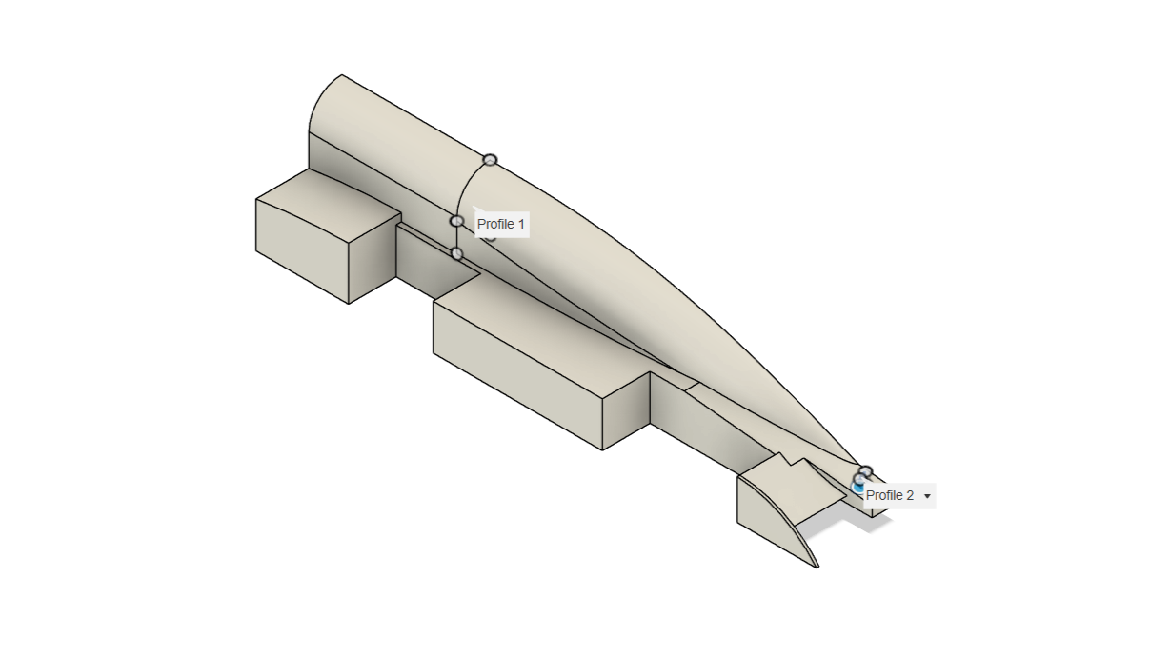

Initially, we would extrude **(mentioned above)** a chamber for the CO2 first and then create a sketch further away and loft **(mentioned above)** the two profiles (the face of the chamber and the created sketch), but this resulted in a gradual curve only at the front of the body. The air flow would separate over the chamber hence, widening the wake and inducing drag.

Our line of thinking then shifted to using forms to create a curvature around the chamber. This resulted in an increased drag due to the lack of continuity from the loft to the created form.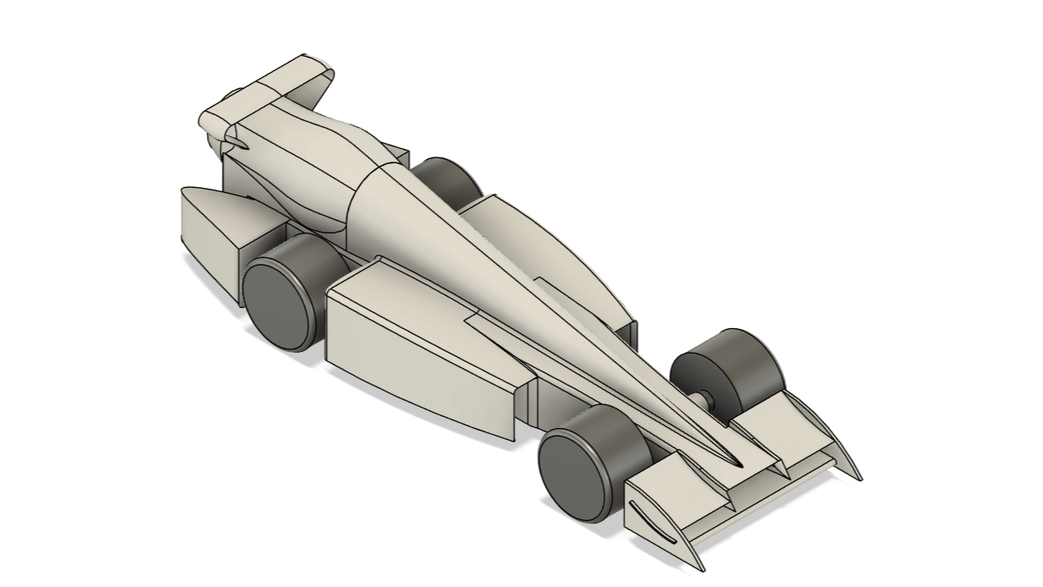

We decided to create two sketches: one at the rear of the car and one on the face of the chamber, both of which consisted of a semicircle. The semicircle at the face was given a longer base by 2mm. On lofting, we were able to produce a body with an exceptional curve.

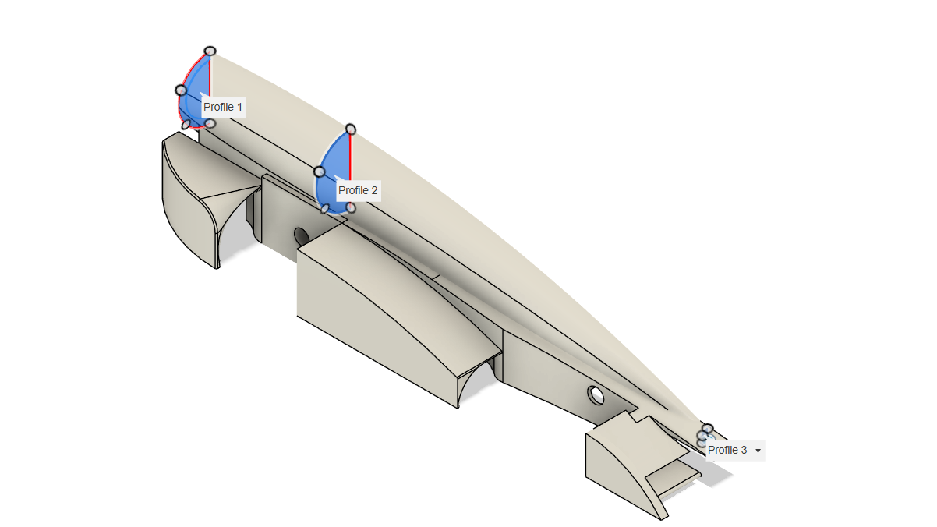

* All the sharp edges along the side/rearpods, nose cone and the junction between the nose cone and the body had been filleted to create smooth surfaces that reduce turbulence and flow separation resulting in a smoother model that is easier to manufacture as well. One of the biggest advantages of these fillets is the improved stress distribution offered, increasing structural integrity.
* To aid in acquiring smooth edges with fillets, we used surfacing. Surfacing allowed for creation of smoother transitions that were precise and continuity. It permitted not only an aesthetic and streamlined design but also simplified the model to encourage easier milling.

**[ADD IN BOX AT THE END?]**

Other Design Concepts

**Diffusers:**

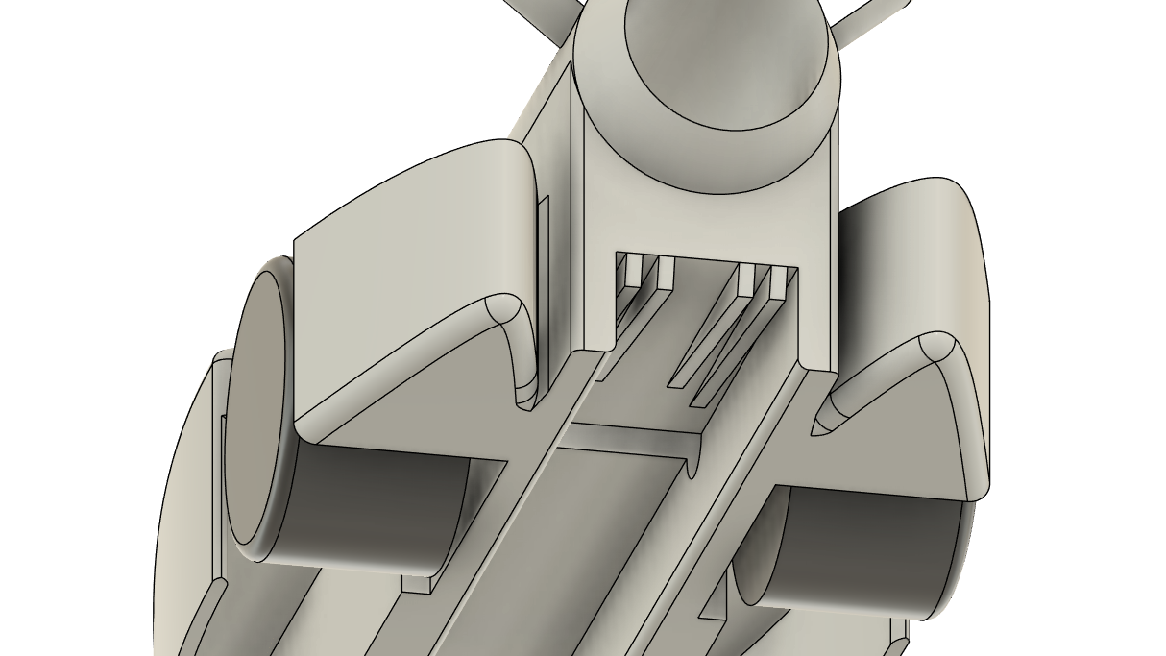

Diffusers are parts at the rear which increase cross sectional area gradually to slow down passage of air to redirect it to the low pressure area in the rear of the car. These helped in reducing the drag significantly at the time, but upon revision of the regulations, we realized that the use of diffusers would result in a broken critical regulation and hence, we dropped the idea.

**Vortex Generators:**

Inspired by F1 cars, we tried to create vortices by adding vortex generators to the front wings to reduce boundary wall separation along the sides of the models but again, we violated critical regulations and had to get rid of them. 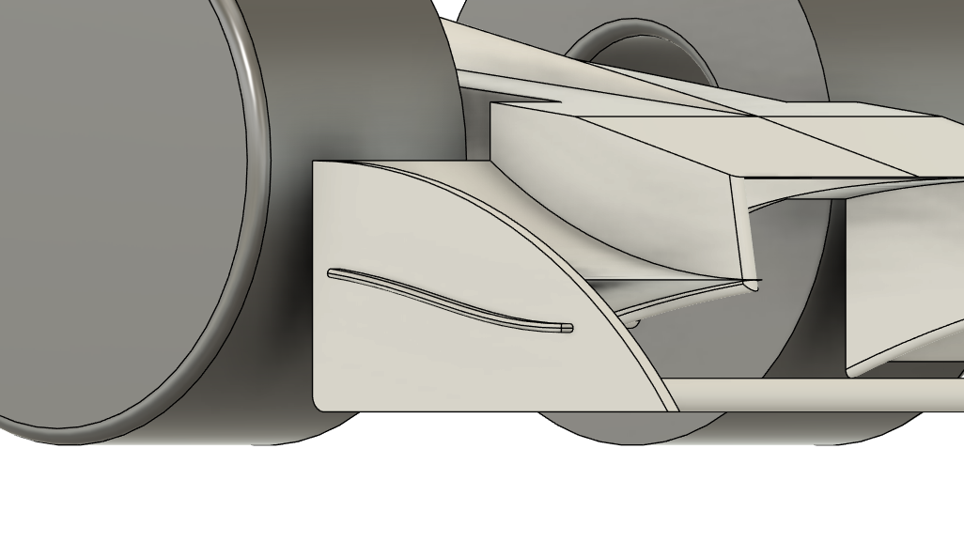

Final Car Analysis

**[Render]**

Prototype Noctua was found to have a drag force of 0.28. After meticulous research and testing, we realized a car that was aerodynamically efficient, structurally sound and aesthetically pleasing.

Our final model, Prototype Noctua, surpassed our initial expectations, compelling us to delve deeply into CAD modeling and achieve new heights in aerodynamics application.

**Analysis Tools:**

**Curvature Comb:**

This tool allows for the analysis of the curvature of a surface. It displays perpendicular lines along the surface (making it look comb-like) whose lengths are directly proportional to the curvature at that point. If the length of the line is longer, the curvature is high and if the length is shorter, the curvature is lower.

Continuity G:

Known as Geometric Continuity and is the continuity between two geometries. It decides the smoothness of a surface.

1. G0: G0 or Positional continuity occurs when two surfaces have a common endpoint. It requires the geometries to meet each other.
2. G1: G1 or Tangential continuity occurs when the two surfaces have the same tangential direction.
3. G2: G2 or Curvature continuity occurs when the two surfaces have the same curvature, ensuring a smooth transition.

**Zebra Analysis:**

Zebra Analysis utilizes stripes identical to a Zebra’s stripes (hence the name) to analyze the continuity and smoothness of a surface. Parallel lines are produced over a surface and the deviation of the ‘stripes’ is visualized conveying the irregularities of the curvature. To make certain there are no irregularities, ensuring that the distance between consecutive lines is consistent.

With the above analysis, we can interpret that the model has somewhat consistency in the distance between each line. The view of Zebra Analysis changes when the model is moved and hence, we get a different representation at every view point. 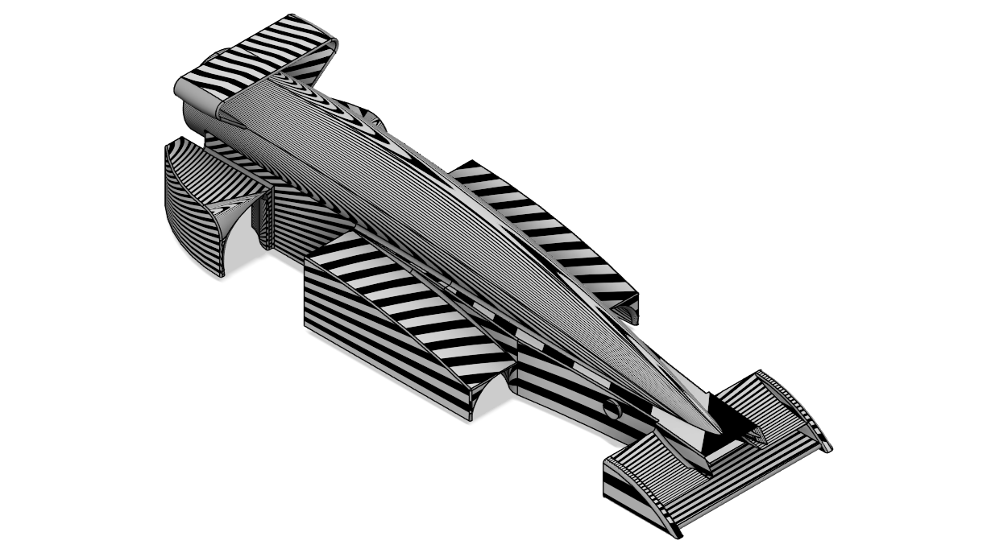

**Accessibility Analysis:**

This tool evaluates whether a given geometry can be accurately manufactured using CNC machines. Accessibility, in this context refers to whether a model can be reached by the end mills and whether there is a chance of potential collision of the tool with the material.

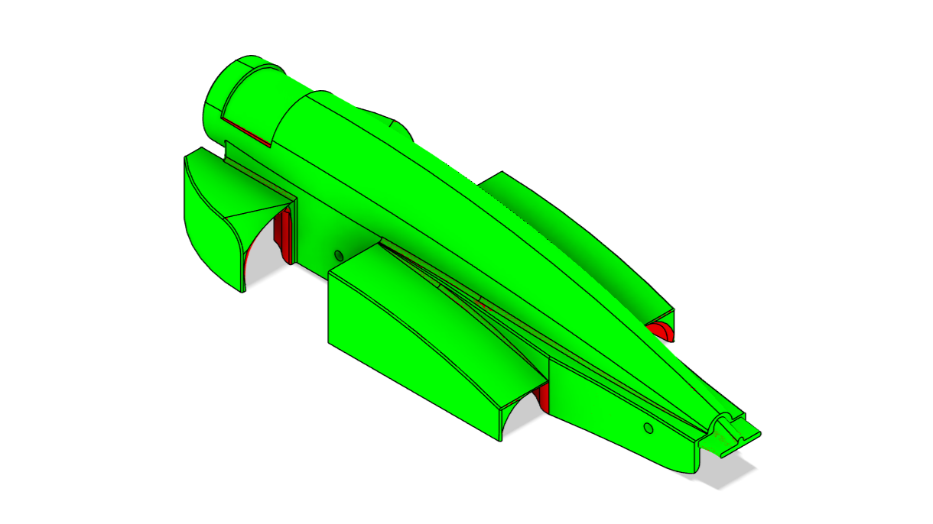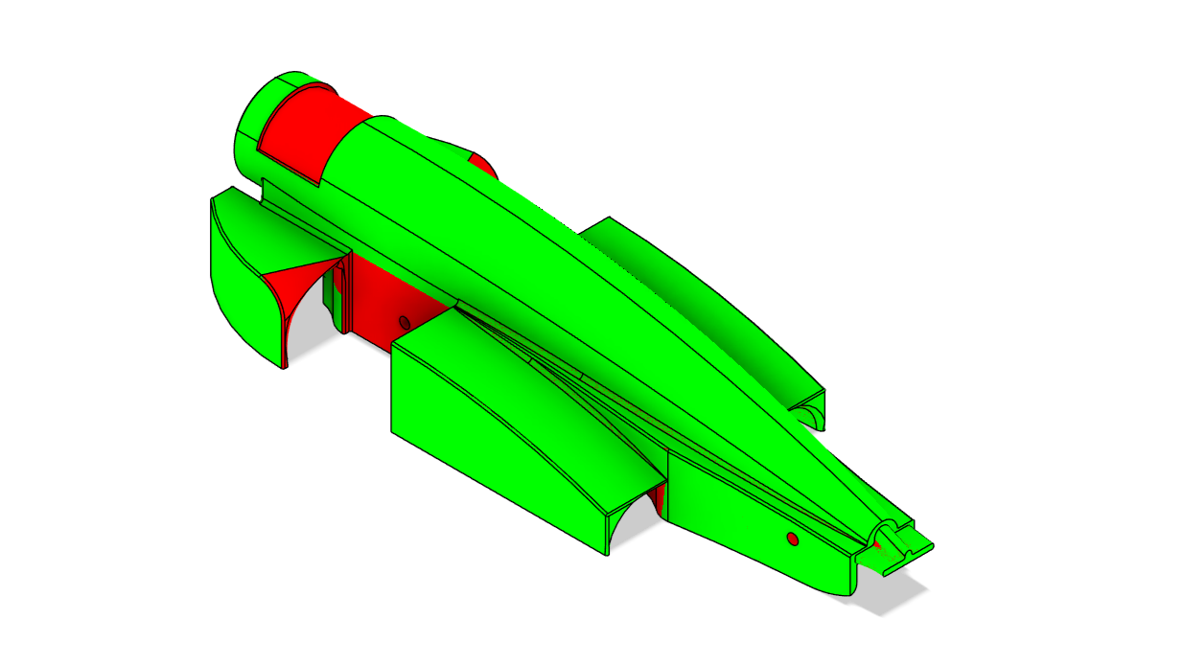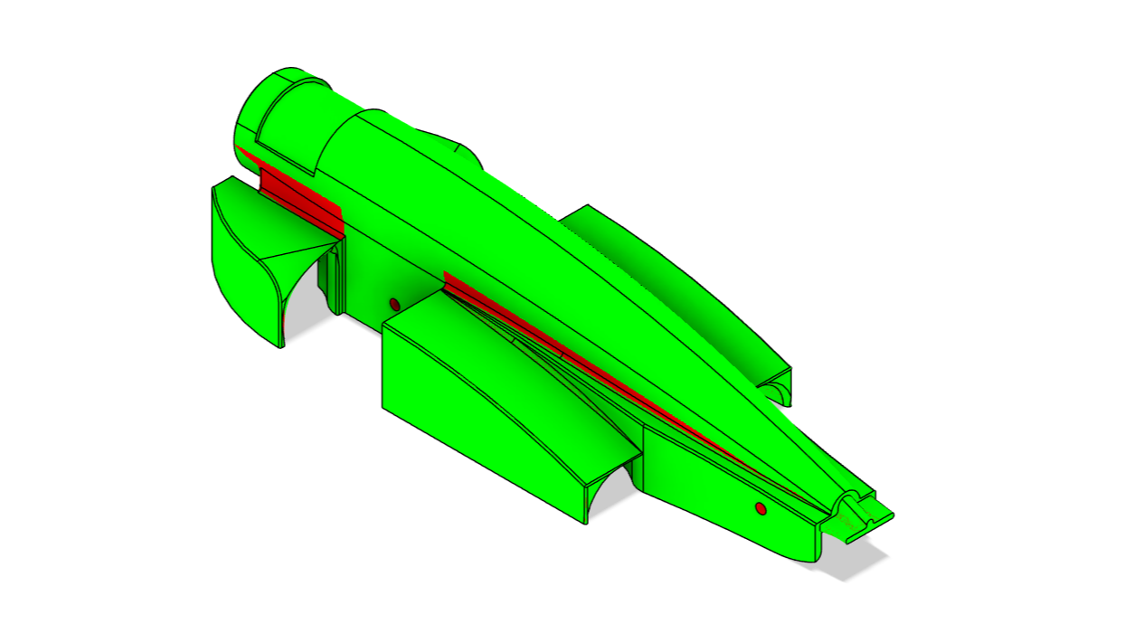

From the above three representations of accessibility from each plane, it can be inferred that the model will not have issues with the CNC process. The axle holes are not considered as the end mill does not have the required diameter to CNC the feature.

[**Couldn’t think of a place to enter here but if u feel its somewhere better within final car analysis then go ahead]**

‘Noctua’ is derived from ‘Athene Noctua’ or Owl of Minerva. The Owl of Minerva symbolizes the arrival of wisdom and knowledge after the events have unfolded. Georg Hegel, a German philosopher, popularized the phrase “The Owl of Minerva spreads its wings only with the falling of dusk” representing just that.

This is exactly what we experienced during the constant designing of models. We were not equipped with the knowledge to create such a remarkable model, it only came to us after thorough trial and error and extensive research.

Our initial goal of achieving a drag force of 0.4 or lower became obsolete after we realized what the Noctua was truly capable of. Through practice, we managed to achieve a streamlined body that could withstand the forces presented to it during the races.

The front wing achieved its initial goal of creating downforce while also keeping the airflow away from wheels. It was also able to energize airflow hence decreasing boundary layer separation and increasing downforce and thus, improving stability and grip.

The rear wing realized its task of being a low drag element that redirects airflow towards the wake of the car while providing downforce and hence stability.

The sidepods beautifully carry the oncoming airflow from the wheels and elegantly redistribute it over the rest of the car body adding to the directional stability and grip.

The rear pods allow the latency in airflow separation hence, averting the airflow towards the rear of the car. They also carry the airflow over the rear wheels and help reduce turbulence which adds to the overall aerodynamic efficiency of Prototype Noctua.

Hence, Prototype Noctua helped us in realizing our own potentials and to what extent our boundaries could’ve been pushed to. With Noctua, we achieved new horizons.